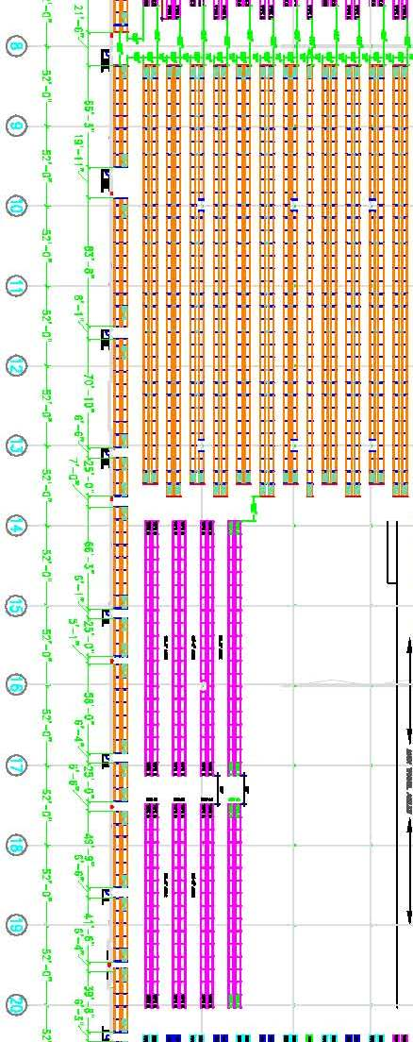
215
221
PACKOUT
Cart Prep
BS Bin Shelving
FL2
FL1
FL3
216
217
218
219
220
ZONE 200s
ZONE FLOW123
ZONE BS (Bin Shelf)
ZONE
FLOOR

